Khramenkov Stanislav Vladimirovich

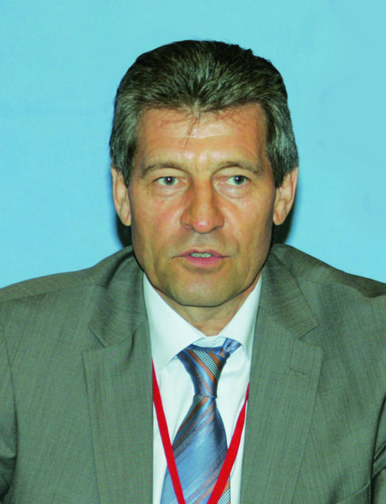

PhD (Engineering), Professor
member of the Board of the Moscow Confederation of Industrialists and Entrepreneurs
Honored Member of the Russian Water and Wastewater Association
Acting Member of the Russian Academy of natural sciences

Education, science degree, academic rank
1977 graduated from the Moscow Public Utilities and Civil Engineering Institute (in-service training); in 1991 finished the Academy of National Economy with the specialty in management.
In 1999 passed Ph.D. defense on «The strategy of providing for the operational control and safety of the domestic water supply system»

Honorary degrees and awards
Honored Worker of RF Housing and Utility Sector
Russian Federation Honorary Builder
Honorary Builder of Moscow

Area of expertise
Water supply and wastewater disposal. Development of new legislative acts related to water supply and wastewater management. Management and coordination of the implementation of large-scale engineering projects of reconstruction, construction and upgrade of water and wastewater treatment facilities

Editorial Board
Member of the editorial board of «Vodosnabzhenie i Sanitarnaia Tekhnika» Journal

Scientific indices
H-index 5
SCOPUS Index 5

Participation in the conferences
Participation with presentations in All-Russia Congresses of Vodokanals, International ECWATECH Water Forums

Publications
Author of more than 250 scientific papers
Author of 8 monographs
1. Khramenkov S. V. [Strategy of developing water supply and wastewater disposal systems in the Russian Federation]. Vodosnabzhenie i Sanitarnaia Tekhnika. 2013. No. 7. (In Russian).
2. Khramenkov S. V., Kozlov M. N., Shchegol'kova N. M., Vaniushina A. Ia., Agarev A. M., Grachev V. A. [The use of biosoils with addition of water and wastewater sludge for technical crop growing]. Vodosnabzhenie i Sanitarnaia Tekhnika. 2012. No. 10, p. 72. (In Russian).
3. Khramenkov S. V., Pakhomov A. N., Strel'tsov S. A., Kevbrina M. V., Vaniushina A. Ia., Agarev A. M. [Improving the efficiency of wastewater sludge treatment with the use of high-temperature hydrolysis prior to digestion]. Vodosnabzhenie i Sanitarnaia Tekhnika. 2012. No. 10. p. 55. (In Russian).
4. Khramenkov S. V., Primin O. G., Orlov V. A. [Computerized support of the strategy of planning the Moscow water pipeline rehabilitation]. Vodosnabzhenie i Sanitarnaia Tekhnika. 2012. No. 1, p. 3. (In Russian).
5. Khramenkov S. V., Primin O. G. [Problems and methods of reducing water losses]. Vodosnabzhenie i Sanitarnaia Tekhnika. 2012. No. 11, p. 31. (In Russian).
6. Khramenkov S. V. [The objectives of water industry development to ensure clean drinking water supply of the Russian population]. Vodosnabzhenie i Sanitarnaia Tekhnika. 2011. No. 5, p. 15. (In Russian).
7. Khramenkov S. V. [Mosvodokanal at the new development stage]. Vodosnabzhenie i Sanitarnaia Tekhnika. 2011. No. 10, p. 3. (In Russian).
8. Khramenkov S. V., Generalov N. S., Baranov S. V., Artiushin M. V. [Advanced methods of the Moscow water supply upgrade]. Vodosnabzhenie i Sanitarnaia Tekhnika. 2011. No. 10, p. 30. (In Russian).
9. Khramenkov S. V., Pakhomov A. N., Kozlov M. N., Nikolaev Iu. A., Kazakova E. A. [Industrial testing biological and chemical removal of phosphorus at the Moscow wastewater treatment facilities]. Vodosnabzhenie i Sanitarnaia Tekhnika. 2011. No. 10, p. 49. (In Russian).
10. Khramenkov S. V., Khrenov K. E., Fedunets B. I., Kosolapov A. F., Pakhomov A. N. [Polymer lining of reinforced concrete blocks for sewer construction]. Vodosnabzhenie i Sanitarnaia Tekhnika. 2011. № 3, p. 13. (In Russian).

Indices of innovation activity:
Holder of more than 50 patents and inventor's certificates

Development of Government Programs
Participated in the development of the Federal special-purpose programs «Clean water», «Housing», «On water supply and wastewater management» Federal Law etc.

Regional education system indices
Professor, Water Supply Department, Moscow State University of Civil Engineering

Trained three post-graduates for PhD degree

