Shvetsov Valeriy
Nikolaevich

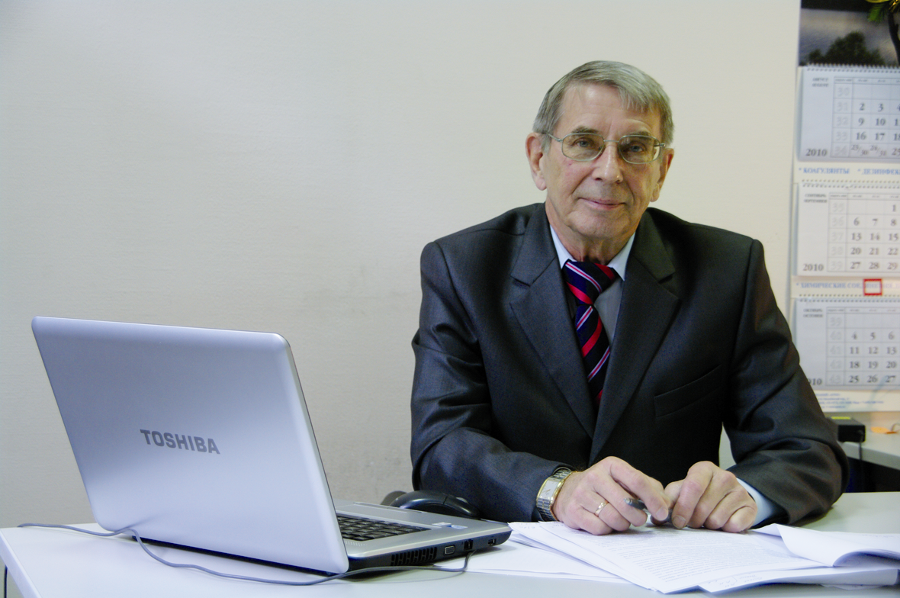

Doctor of Engineering, Professor
RF Honored Worker of Science (2002)
Laureate of the Russian Federation Government Prize for science and engineering (2010)
Since 1993 Editor-in-Chief of the «Water Supply and Sanitary Technique» monthly scientific, technical and engineering journal

Education and science degree
In 1966 graduated from the Moscow Civil Engineering Institute named after Kouibyshev by specialty «Water and Wastewater Management»
In 1973 defended a thesis on «The use of bulk oxygen to enhance the process of biochemical wastewater treatment» for PhD degree
In 1979 was awarded the title of Senior Research Fellow
In 1989 defended a thesis on «Advanced biological treatment of concentrated wastewater» for Doctor of Science degree
In 1993 was awarded the title of Professor

Academic awards
Honored Worker of Science of Russia
Russian Federation Government Prize for science and engineering

Scientific interests
Biological treatment of industrial and municipal wastewater
Research and development of technologies of enhancing the process of wastewater biological treatment with the use of pure oxygen and high biomass concentrations. Development of design methods and rational flow diagrams of biological treatment of highly-concentrated industrial and municipal wastewater
Theoretical basis of designing wastewater biological treatment processes based on enzyme kinetics equations was developed that underlay the acting regulatory documents. Under his guidance a brand new advanced method and facilities of natural water biological treatment and advanced treatment of municipal wastewater – «biosorber» and biomembrane technologies were developed

Senatus academicus and research management
Chairman of the Doctoral Council at VODGEO Scientific Research Institute
Member of the Expert Council of RF State Commission for Academic Degrees and Titles in civil engineering and architecture

Editorial staff
Editor-in-Chief of the «Water Supply and Sanitary Technique» monthly scientific, technical and engineering magazine

Scientific indices
Participated in «Water: Ecology and Technology ECWATEC 1994-2012» International Congress. He was the organizer of the international conference dedicated to the 100th anniversary of the journal «Water supply and sanitary engineering»

Publications
Author of more than 140 scientific papers

1. Stepanov S. V., Shvetsov V. N., Morozova K. M., Beliakov A. V., Blinkova L. A. [Investigating nitrification-denitrification technologies of oily wastewater treatment]. Vodosnabzhenie i Sanitarnaia Tekhnika. 2013. Nо. 5, pp. 50–58. (In Russian).
2. Shvetsov V. N., Alekseev V. S., Morozova K. M., Smirnova I. I., Semenov M. Iu. [Biosorption membrane technology of restoring the quality of ground waters polluted with oil products]. Vodosnabzhenie i Sanitarnaia Tekhnika. 2013. No. 1, pp. 30–36. (In Russian).
3. Shvetsov V. N., Morozova K. M., Smirnova I. I., Domnin K. V., Arkhipova E. E. [Extraction of heavy metal ions from municipal effluent after biological treatment]. Vodosnabzhenie i Sanitarnaia Tekhnika. 2012. No. 7, pp. 59–64. (In Russian).
4. Shvetsov V. N., Morozova K. M., Smirnova I. I., Domnin K. V., Arkhipova E. E. [Designing nitrification-denitrificaton retrofit at the biological treatment facilities]. Vodosnabzhenie i Sanitarnaia Tekhnika. 2012. No. 7, pp. 53–59. (In Russian).
5. Klimov V. A., Iavtushenko M. V., Ruzaev V. I., Beliaeva S. D., Shvetsov V. N. [Municipal wastewater in Podolsk will be treated with advanced technologies]. Vodosnabzhenie i Sanitarnaia Tekhnika. 2012. No. 2, pp. 3–10. (In Russian).
6. Shvetsov V. N., Morozova K. M., Fesenko L. N., Skriabin A. Iu., Teremiazeva O. V. [Biosorption membrane technology for prevention of chlororganic and bromorganic compound formation in the Don River water]. Vodosnabzhenie i Sanitarnaia Tekhnika. 2012. No. 2, pp. 7–13. (In Russian).

Indices of innovation activity
Patents
60 patents and inventor's certificates
List of patents received for the past 5 years (2008–2013)
1. Installation for removing organic compounds from wastewater. Shvetsov V. N., Morozova K. M., Kiristaev A. V., Smirnova I. I. Useful model patent No. 74122 of 20.06.2008.
2. Method of removing organic compounds, nitrogen and phosphorus from wastewater. Shvetsov V. N., Morozova K. M., Kiristaev A. V., Smirnova I. I. Patent No. 2351551 of 10.04.2009.
3. Method of removing organic compounds from natural water. Shvetsov V. N., Morozova K. M., Semenov M. Iu., Smirnova I. I. Patent No. 2370460 of 26.05.2009.
4. Method of removing organic compounds and nitrogen from wastewater. Shvetsov V. N., Morozova K. M., Nechaev I. A., Pushnikov M. Iu. Patent No. 2210549 of 20.08.2003,

Development of Government Program

Participated in developing and implementing of the federal special-purpose programs:
«Environmental Safety of Russia», «Rejuvenation of the Volga», «Delivering drinking water to the Russian population»

Regional education system indices
Trained 8 post-graduates for PhD

Awards
Awarded with Order of Friendship of Peoples, medal «In Honor of 850th Anniversary of Moscow»

